Storyboard- Bad Santa

Intro
Iris and kittens are asleep in snow scene. Bad Santa and Bad Bear drive hrough on motorcycles and kittens disappear. Toy rocket flies through and drops jack-in-the-box. Jack-in-the-box pops open and Jack says in speech bubble “25 (pic of star)”. After 3 seconds the star fades to gif of Santa in star laughing (add “Ho Ho Ho”). Another toy rockett flies in and hits the jack-in-the-box which explodes and disappears. Signer in corner signs “ Oh No, bad Santa has stolen the kittens. He wants 25 stars to give he kittens back. Please help Iris collect 25 stars. The stars are in igloos. Inside the igloos are alligators, spiders , snakes and bad cats guarding the stars. You must tell Iris where the bad animal is. Iris will do magic and get the star. Good luck”.
Iris’ rocket plane flies in and lands and Iris gets in and flies away.

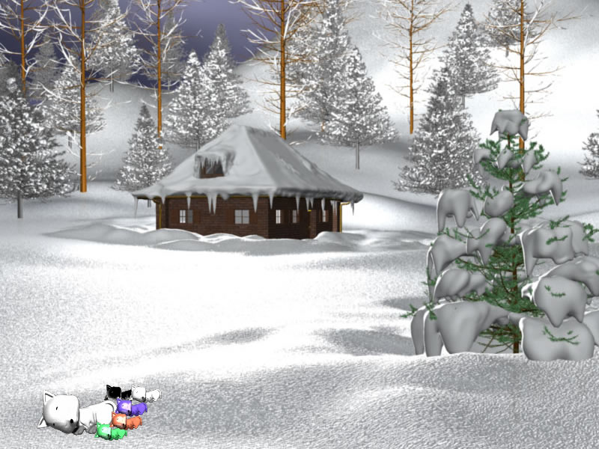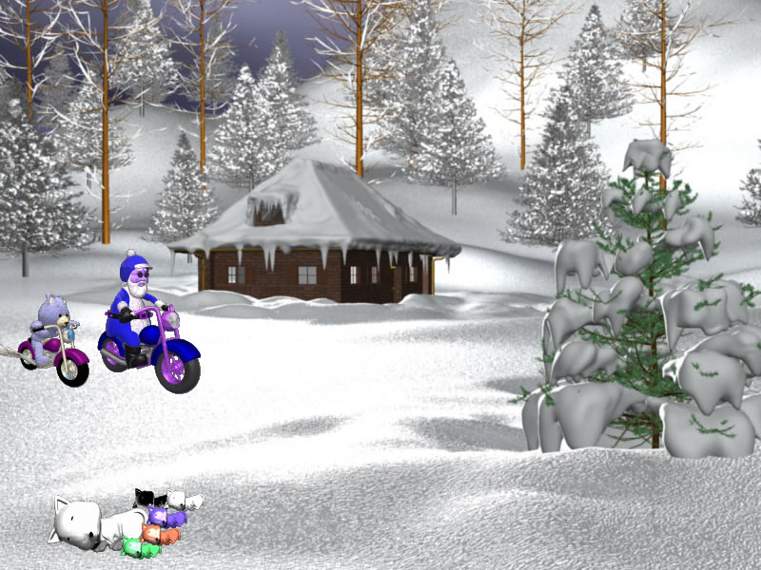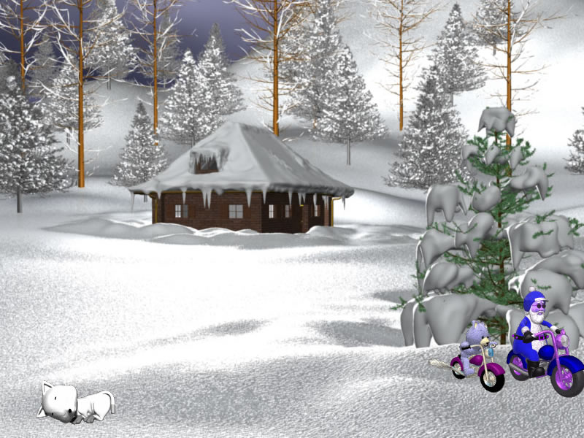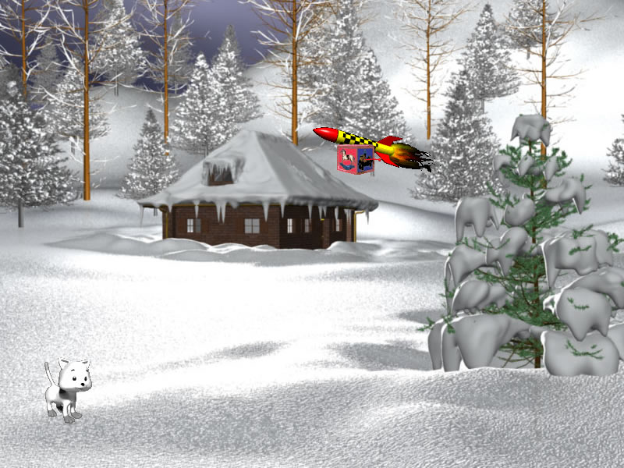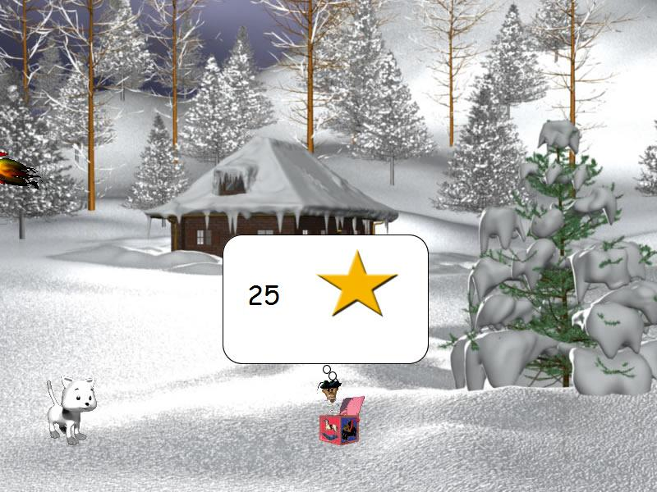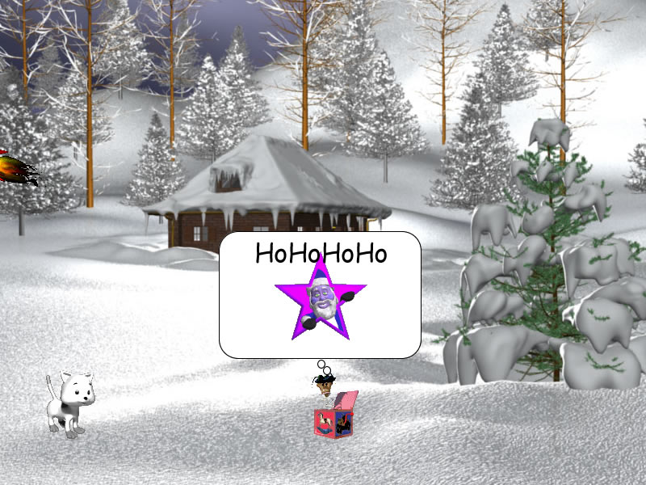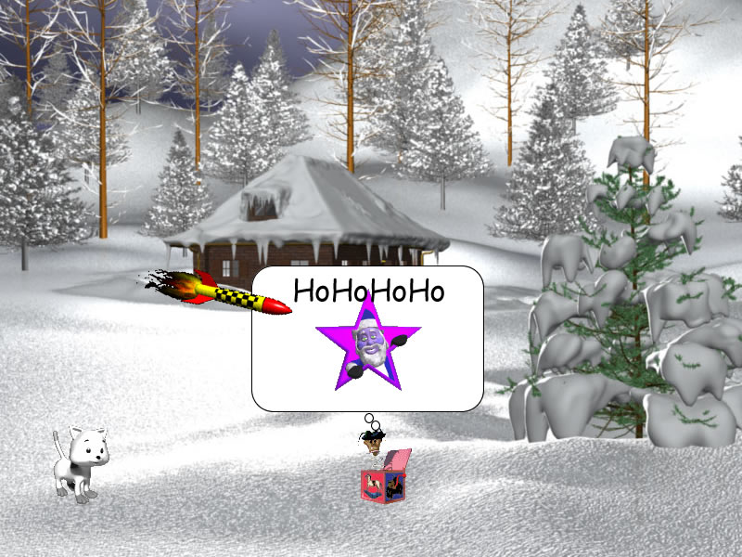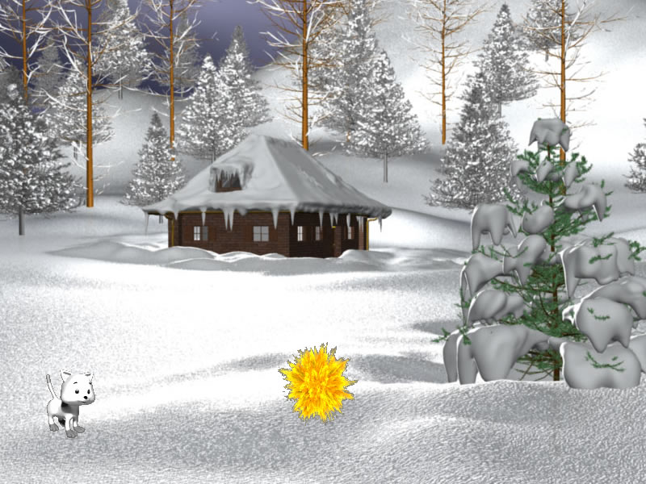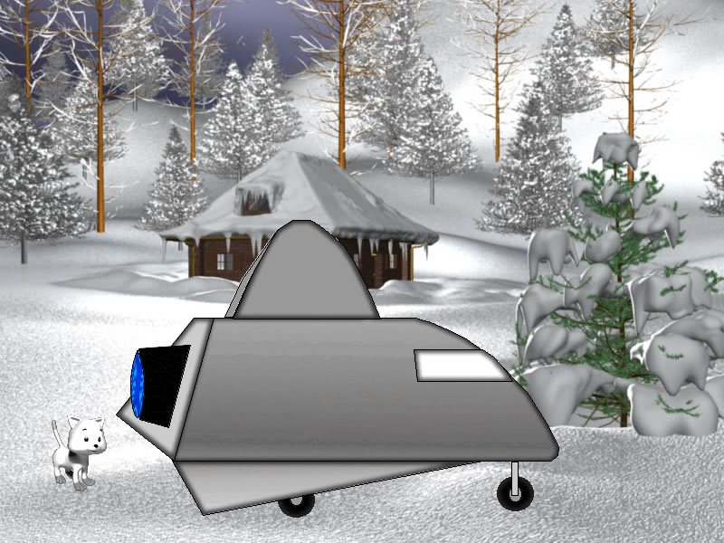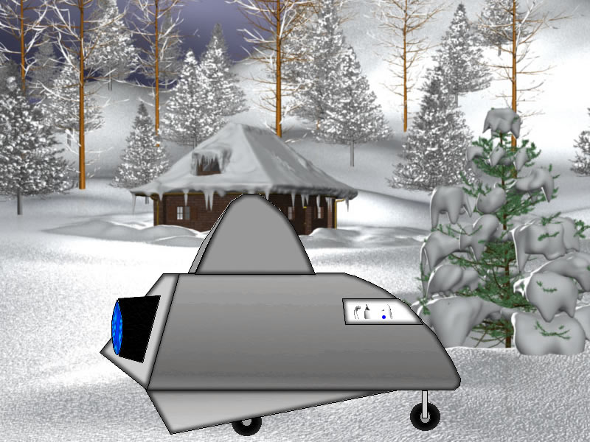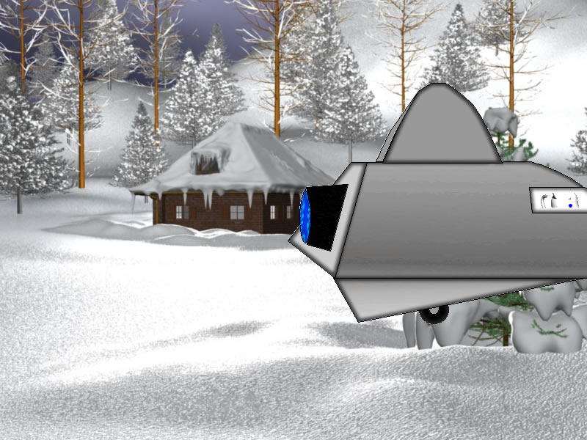

Flythrough
Have help video to side (bad santaintro 2_copycat.mov) that plays first time kids see the flythrough that says
Iris flies rocketplane through snowfield collecting snowflakes by flying under the snow cloud and avoiding fireballs. The objects in sky(cloud and fireball) and on ground (trees, barrels, etc…) are scrolling from top of screen to bottom as kids fly rocketplane.
Keep score of number of snowflakes collected (add 5 each time). If rocketplane hits fireball, subtract 5 snowflakes. (Have more clouds than fireballs.) When kids see igloo they land at igloo(game should last about 15 seconds). Make scrolling stop when igloo appears so kids can land there.

(There needs to be 20 different flythrough scenes. When kids return to flythrough from a room a random flythrough scene should appear)
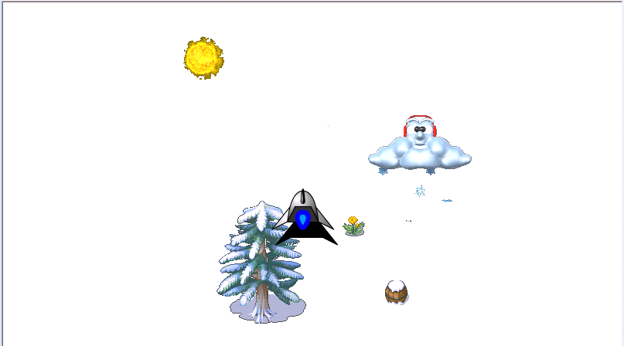
Scene switches to room scene

Room scene
When Iris enters room Kids can see who protects a star (e.g., alligator on green wall) Kids tell Iris. If kids are wrong a question mark appears above her head.
If correct Iris goes and poofs villain with a magic snowflake(turns it to a snowman) and gets star. Star flies over to score area and score increases by one . Iris turns around and goes out of igloo and flythrough scene starts again
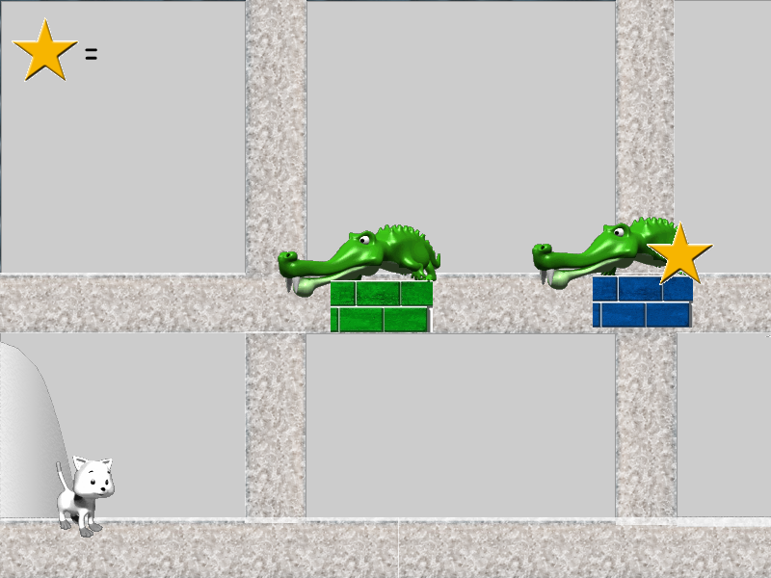

Pirate Room
Occasionally when Iris enters a room she will be in a pirate scene. Iris and BadBear doing wheelie with numchuck will fight while Bad Elf takes (maybe -5) stars which will be subtracted from total. When this is done the bad guys fade out and Iris out of to go to rocketplane. (Make this animation)
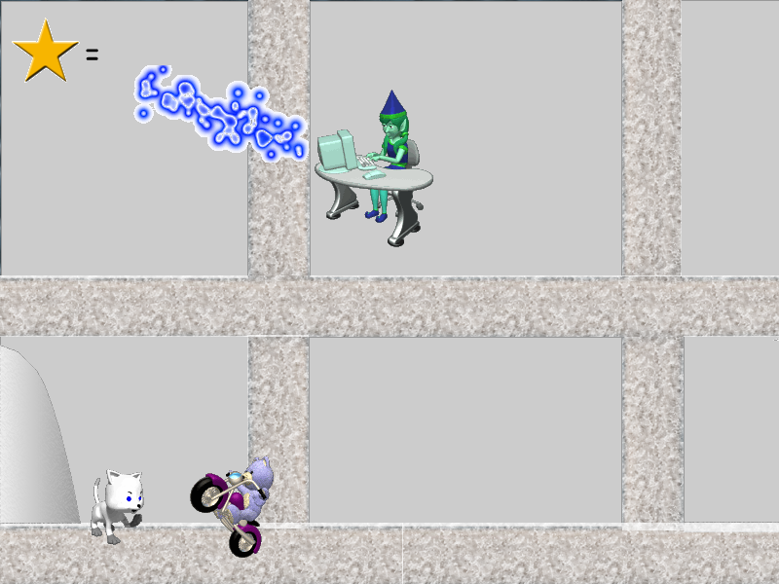

Bonus Room
There are 5 stars to be gotten to make up for the 5 the pirate stole.

After Bonus room the Pirate room will appear or vice-versa so score is not affected. The rooms cancel each other out.
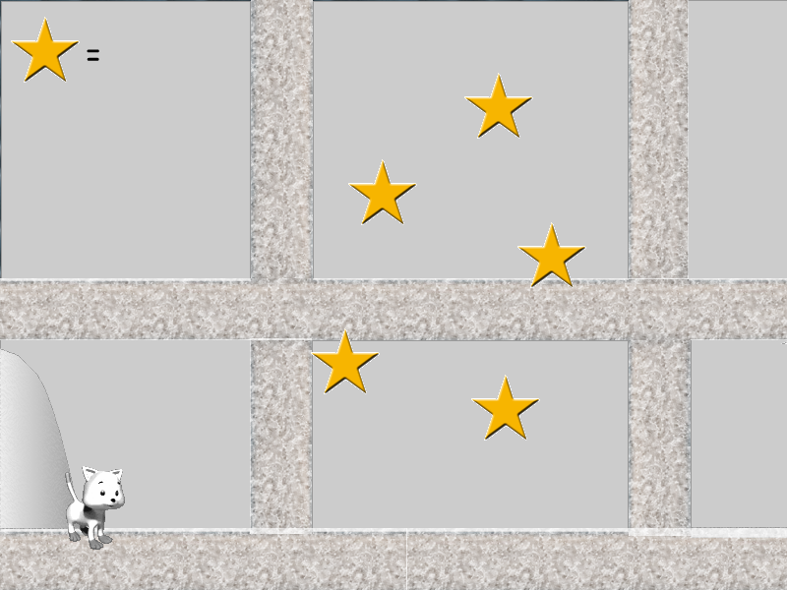
No star room
Have a room where there are no villains or stars. It will simply be an animation in which Iris looks puzzled (? In thought bubble) and then walks out.

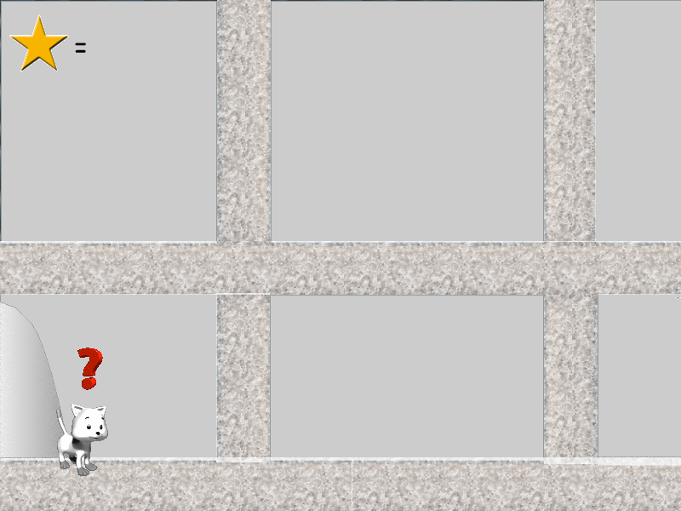

Game end
When kids have 25 stars they go to the kidnappers hideout to rescue the kittens and pull a “Puss in boots” trick so that the kittens go free and Iris keeps the stars. She turns the bad guys into snowmen. Then fade to closing scene of Iris and kittens with ILY.

